Morgan Buterbaugh

Indiana University of Pennsylvania

December 2022

Effects of Covid-19 Educational Mode Change on Student Mathematical Knowledge

**Abstract**

My research investigates the impact of the Covid-19 pandemic on high school students’ ability to progress mathematically in preparation for college math classes. It explores students’ opinions on how the pandemic affected their math learning and analyzes how their actual group math performance at Indiana University of Pennsylvania compares with their collective opinions. Part of my research consists of an online Qualtrics survey that was sent to all Intermediate Algebra Spring 2022 and Fall 2022 students, which is complemented by institutionally provided identity-wiped data through the IUP Department of Mathematical and Computer Sciences. We compare the two cohorts and determine if there was a difference in mathematical knowledge between the two cohorts, and if that difference could be primarily attributed to whether the pandemic lockdown occurred during the sophomore or junior high school year for the students. As seen at IUP, students who have a lower placement in their mathematics course sequence are more likely to switch out of a natural science major and are more likely to not finish their college degree. Studying the negative effects of the pandemic on math knowledge can help to lead to an understanding of how much more remediation might be needed for these students.

**Introduction**

In March 2020 the United States was greatly impacted by the Covid-19 Pandemic. Due to uncertainty and the goal to reduce exposure and transmission, many stay at home orders were put in place, and many high-traffic areas were shut down. These include stadiums, arenas, stores, restaurants, and most relevant to this study, schools. Most high schools shut down mid-March 2020, and by the end of March, there were little to none open for in-person instruction. This caused schools to teach virtually and remotely. The 2020-2021 school year began in an online and/or hybrid format as well, transitioning to higher percentages of in-person learning as the school year progressed.

With online and hybrid learning comes the struggle of technology issues, access to resources, and the changed mode of instruction. Since high school classes are not traditionally designed to be taught online, many students struggled with the new format, particularly combined with the mental strain caused by the pandemic and isolation. My goal is to understand how this educational mode change affected the mathematical knowledge and perceptions of learning mathematics for students who were high school sophomores or juniors.

Not only has the pandemic had an effect of student knowledge, but pre-pandemic, students were already behind in math. “Before the pandemic, NAEP test scores in both reading and math declined for 13-year old students, the first drop registered since the tests started to be administered in 1969” [2]. It is to be expected that after the pandemic that students would continue to be behind in math. Student performance on math standardized testing also decreased. “Student test scores declined across the country, particularly in math, and not one state saw an increase” [2]. Many students are not at grade level math knowledge compared to pre-pandemic. “Grades are telling the tale: students are struggling in math. In math departments across the country, professors and administrators say more students need more support” [1].

To achieve my goal of understanding how this educational mode change affected the mathematical knowledge and perceptions of learning mathematics for students who were high school sophomores or juniors, I conducted research at Indiana University of Pennsylvania. I surveyed Spring 2022 and Fall 2022 students who have taken or were currently enrolled in MATH 100, Intermediate Algebra. I chose MATH 100 as the focus group since this class is a prerequisite for College Algebra. At IUP, MATH 100 is set up as a self-paced class that uses the adaptive learning system ALEKS. This is also the same media used for all the initial math placement assessment that every student must complete when first starting at IUP.

For the purposes of this study, the term “lockdown” was defined as the period of time between March 2020 and the time that the student went back to high school in an in-person setting 4-5 days per week. All participants in this study were 18 years or older.

**Methods and Materials**

The data for my research project consists of IUP institutional data, ALEKS website data, and data from an IRB-approved survey. To attain the data for my research project, I worked with IUP mathematics faculty members Dr. Dan Radelet, who attained the IUP institutional data through an IRB and the ALEKS website data, and Dr. Rick Adkins, who helped to de-identify the data.

The IUP institutional data consisted of the number of times a student had taken the initial math placement assessment, how long each placement assessment lasted, and the placement results. The ALEKS data consisted of the initial assessment score, scores for three exams, final assessment score, total time spent in the class, and the number of topics learned per hour. The survey consisted of 36 questions and was created using Qualtrics. The questions from the survey is located in the appendix.

The survey was IRB-approved on July 12, 2022, with IRB Log # 22-103-IUP (IRB). It was sent via email on October 5, 2022 and ended on October 14, 2022. In order to raise the participation for the survey, an incentive of four $50 Amazon gift cards were offered. There were 10 responses from the Spring 2022 survey and 80 responses from the Fall 2022 survey, totaling 90 out of 339 contacted students, which is 26.55% of the cohort. Although this may seem small, the return rate at IUP is around 12-15%. The informed consent text that was included at the beginning of the survey, email message, and eligibility for the gift card incentives are located in the appendix.

**Results and Discussion**

When analyzing the survey results, I had to keep in mind that student self-reporting could possibly be inaccurate [3].

Of the 90 survey respondents, 4.65% were out of school, 8.14% were seniors, 18.61% were juniors, 68.60% were sophomores. Of those who responded, 85.88% participated in hybrid/remote learning during lockdown in which 8.22% were graded for correctness, 27.40% for completion, and 64.38% for both correctness and completion. While learning during lockdown, 81.33% of respondents felt they did not learn math during lockdown as well as they did while in person. A little more than half of respondents stated that the pandemic negatively affected their math abilities, and around 60% felt their math confidence level lowered. During lockdown, students asked for less help than when they learned in person. Around 13.33% said they asked lots of questions, 25.33% asked questions occasionally, 24% asked very minimal questions, and 37.34% agreed that they asked no questions with hybrid/remote learning during lockdown.

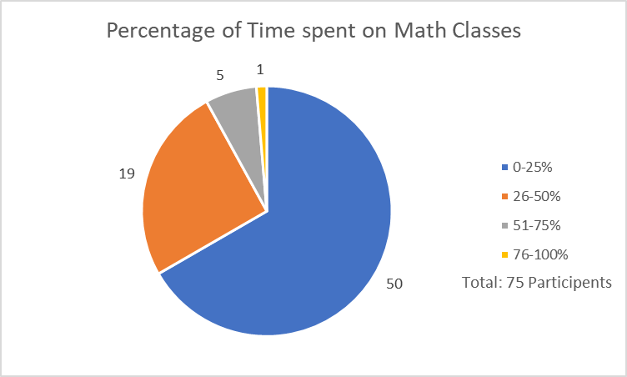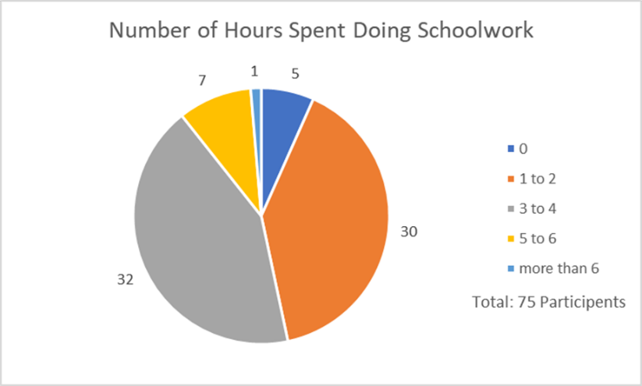The participants were asked what math class they had last taken before college, where a majority answered pre-calculus/college algebra. 7 respondents said algebra, 5 for geometry, 15 for trigonometry, 27 for pre-calculus/college algebra, 13 for calculus, 17 for statistics/probability, and 6 said another type of math class. They were also asked to estimate the amount of time they spent doing their schoolwork during lockdown, and how much of this time was spent on math. As seen in the *Figures 1* and *2*, we can see that a vast majority spent between 1- and 4-hours doing schoolwork, and around 25% or less of this time was doing math related classwork. As was known, students were already falling behind in math before the pandemic started, so it comes as no surprise that almost all the participants felt as though they were behind in math compared to where they thought they should be academically, due to the pandemic.

*Figure 2*

*Figure 1*

After in-person learning had started making its way into classrooms again, many of the respondents declared they found it easier to learn in this type of setting. Around 83% of those who responded said they asked questions and for help the same amount or more during in-person learning. Well over half of those who responded stated that they were less interested in learning after lockdown, while 23% stated they were more interested in learning, and the rest stated they were indifferent. When it came to learning math after lockdown and hybrid/remote learning 36% said that they had less of an interest, 17% said they had more of an interest, and the remaining 47% said they had the same level of interest as they had before lockdown. Two-thirds said the pandemic negatively affected their overall learning, with almost 55% saying the pandemic negatively affected their math abilities.

Studying for math post-pandemic after lockdown was vastly different than studying for math pre-pandemic. 24.39% disclosed that they studied less, while 75.61% said they studied about the same or more. Before lockdown, a vast majority spent less than 25% on math homework. However, after lockdown a majority spends 26-75% of their time on math homework. *Figure 3* graphically shows the results of time spent on math class after lockdown. Almost 60% said their math confidence level had lowered, 39% said it had stayed the same, and less than 1% said it had gotten higher post-pandemic learning.

*Figure 3*

When it comes to college level math, there were many different responses and feelings from the respondents. 43% of the respondents felt their high school math experience failed to prepare them for college level math, and two-thirds believe this is due to the pandemic. Almost three quarters felt unprepared for the college math placement exam. Around 48% of those who responded felt they were placed in too low of a math class at IUP, 48% felt they were placed in the correct math class, and 4% felt they were placed in too high of a math class. For the workload of college work, a majority spends 3- to 4-hours doing their work, with around half of this time being for math classes. *Figures 4* and *5* show the distribution of data. When compairing the amount of time spent on math classes during and after lockdown, there is a is noticeably a **Chart, pie chart
shift towards spending more time doing both schoolwork and work for their math classes.

*Figure 5*

*Figure 4*

Examining the IUP institutional data, I found the average and median scores for the initial math placement assessment for the 2019, 2021, and 2022 academic years. Looking at *Figure 6*, we see that a the trendline has a negative slope. This indicates that the scores for the initial math placement assessment have dropped around 5% from 2019 to 2022.

Analyzing the ALEKS data, I calculated the average and median for the initial mastered (initial assessment), first exam, total knowledge (final assessment), number of topics learned per hour, and total time spent in the class. Along with this information, I also calculate the test average course grade by using the formula

I assessed this information for Fall 2019, Fall 2021, Spring 2022, and Fall 2022. I chose to omit Spring 2020, Fall 2020, and Spring 2021 since this was during the time of lockdown. The chart in *Figure 7* contains all the information from analyzing the ALEKS data, and the chart in *Figure 8* contains the test average course grades.

*Figure 6*

*Figure 7*

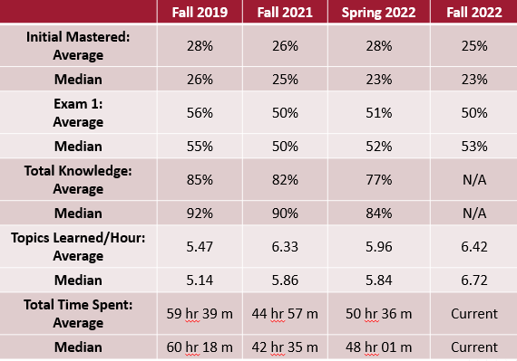

*Figure 8*

**Conclusion**

When comparing the Spring 2022 and Fall 2022 cohorts together, there does not appear to be any noticeable difference, which could be due to the fact that there were so little respondents for the Spring 2022 survey. In this study there is no difference in mathematical knowledge between the that can be primarily attributed to whether the pandemic lockdown occurred during the sophomore or junior high school year for the students. Many of the respondents felt that they were placed into too low of a math class at IUP, even though they stated that the did not feel prepared for college level math, and MATH 100 is an intermediate algebra class. The educational mode change during the pandemic affected the mathematical knowledge and perceptions of learning mathematics for students who were high school sophomores or juniors in a negative manner.

**References**

[1] Fawcett, E. (2022, November 1). The Pandemic Generation Goes to College. It Has Not Been

Easy. *The New York Times*. Retrieved, from https://www.nytimes.com/2022/11/01/us/covid-college-students.html.

[2] Meckler, L. (2022, October 24). *Scores fall coast to coast, especially in math, under*

*pandemic's toll*. The Washington Post. Retrieved from https://www.washingtonpost.com/education/2022/10/24/pandemic-learning-loss-naep-tests/.

[3] Rosen, J. A., Porter, S. R., & Rogers, J. (2017). Understanding student self-reports of

academic performance and course-taking behavior. *Sage Journals*, *3*(2), 1–14. https://doi.org/10.1177/2332858417711427.

**Appendix**

**Survey Questionnaire:**

For the purposes of this survey, “lockdown” is going to be defined as the period of time between March 2020 and the time that you went back to school in an in-person setting 4-5 days per week.

Read these questions, and rate yourself on a scale of ‘very inaccurate, inaccurate, neutral, accurate, very accurate.”

1. I am always prepared.
2. I feel comfortable around people.
3. I normally avoid taking on a lot of responsibility.
4. I like school.
5. I do my schoolwork/homework.
6. I get chores/work done right away.
7. It is important to me that people are on time.
8. I am a perfectionist.
9. I am interested in abstract ideas.
10. I have difficulty understanding abstract ideas.
11. I am exacting in my work.
12. The pandemic negatively affected my math capabilities.
13. The pandemic negatively affected my overall learning.

1. What year did you graduate high school?
   1. 2019
   2. 2020
   3. 2021
   4. 2022
   5. Other: ________
2. During lockdown, did your school continue to teach mathematics in a hybrid and/or remote manner?
   1. Yes
   2. No

* If yes, was your work graded for correctness, completion, or both?
  + Correctness
  + Completion
  + Both

1. During lockdown, on average how long did you spend doing schoolwork per day?
   1. 0 hours
   2. 1-2 hours
   3. 3-4 hours
   4. 5-6 hours
   5. More than 6 hours

* Of this time, what percentage of time did you spend doing your math work?
  1. 0-25%
  2. 26-50%
  3. 51-75%
  4. 76-100%

1. During lockdown, for your mathematics class, did you ask:
   1. Lots of questions
   2. Occasional questions
   3. Very few questions
   4. No questions
2. What mathematics class were you taking when lockdown happened in spring 2020? (Choose all that apply)
   1. Algebra I
   2. Algebra II
   3. Geometry
   4. Trigonometry
   5. Calculus
   6. Probability and Statistics
   7. N/A
   8. Other: ________
3. During lockdown, did you feel as though you learned mathematics as well as in the classroom?
   1. No
   2. Yes
4. How do you feel your confidence in your mathematical capabilities has been affected over the course of Covid-19?
   1. Gotten worse
   2. Stayed the same
   3. Gotten better
5. Hypothetically, if Covid-19 did not happen, do you think your mathematic capabilities would have:
   1. Gotten worse
   2. Stayed the same
   3. Gotten better
6. During the 2020-2021 school year, did you:
   1. Attend high school
   2. Attend college
   3. Not attend school
7. Do you think your high school experience prepared you for college level math?
   1. Yes
   2. No
8. Did you feel prepared for the college math placement test?
   1. Yes
   2. No

* If not, do you think this was due to Covid-19?
  + Yes
  + No

1. What math class did you last take before attending college?
   1. Algebra I
   2. Algebra II
   3. Geometry
   4. Trigonometry
   5. Calculus
   6. Probability and Statistics
   7. Other: ________
2. Did you feel as though you were placed in the correct college math class?
   1. Yes
   2. No

* If not, do you think you were placed
  + Too high
  + Too low

1. Did you feel prepared for your college math class?
   1. Yes
   2. No

* If not, do you think this was due to Covid-19?
  + Yes
  + No

1. Do you find yourself studying less for mathematics after returning to in-person learning?
   1. Yes
   2. No
2. After lockdown and returning to in-person learning, how was your interest in learning been affected?
   1. It has increased
   2. It has stayed the same
   3. It has decreased
3. Are you less interested in mathematics after returning to in-person learning?
   1. Yes
   2. No
4. After returning to in-person learning, did you find yourself forgetting previous mathematics that you have learned before Covid-19? \
   1. Yes
   2. No
5. Do you find yourself asking for help less often after returning to in-person learning (i.e., homework, classwork, notes, etc.)?
   1. Yes
   2. No
6. Right now, on average how long do you spend doing schoolwork per day?
   1. 0 hours
   2. 1-2 hours
   3. 3-4 hours
   4. 5-6 hours
   5. More than 6 hours

* Of this time, what percentage of time did you spend doing your math work?
  + 0-25%
  + 26-50%
  + 51-75%
  + 76-100%

**Informed Consent Text:**

This is a consent form for research participation in a study titled “Effects of Covid-19 Educational Mode Change on Student Mathematical Knowledge.” It contains important information about this study and what to expect if you decide to participate. This research is being conducted by Morgan Buterbaugh and Dr. Daniel Radelet from Mathematical and Computer Sciences Undergraduate Program, John J. and Char Kopchick College of Natural Sciences and Mathematics at Indiana University of Pennsylvania. This study seeks to better understand students’ opinions on how the COVID-19 pandemic affected their personal opinion about their math learning. This study will ask you a series of questions regarding your personal opinions and attitudes as a math learner during the COVID-19 pandemic and the time since.  
  
Your participation is voluntary:  
Please consider the information carefully. Feel free to ask questions before making your decision whether or not to participate. If you decide to participate, you will be asked to sign this form electronically by clicking a button “I consent” below in place of a written signature. You may print this page for your records or may request a hard copy by contacting Morgan Buterbaugh at GYSZ@iup.edu. If you agree to participate, you can withdraw from the study at any time up to the moment you submit the survey response. If you choose to withdraw while taking the survey, simply close your browser. Once you submit the survey, you will not be able to withdraw your data as we will have no way of knowing which data is yours. If you have questions about this research project, you may email Morgan Buterbaugh (GYSZ@iup.edu) or Dr. Daniel Radelet (dradelet@iup.edu). For questions about your rights as a participant in this study or to discuss other related concerns or complaints, you may contact either Morgan Buterbaugh (GYSZ@iup.edu) or Dr. Daniel Radelet (dradelet@iup.edu).  
  
Duration:  
This study will take approximately 10 minutes to complete. You may leave the study at any time. If you decide to stop participating in the study, there will be no penalty to you, as the study is voluntary. Your decision to leave the study will not affect your future relationship with Indiana University of Pennsylvania.  
  
Risks and Benefits:  
The risks of participating in this research are no greater than those in everyday life.  
  
Anonymous and Confidential:  
Although every effort to protect your anonymity will be made, no guarantee of Internet survey security can be given as, although unlikely, transmissions can be intercepted and IP addresses can be identified. All responses received will be anonymous and de-identified. Privacy and confidentiality of subjects is protected.  
  
Incentive: A chance to win Amazon gift card(s) that sum to $50 in total will be awarded to four random students who participate in this survey. (More information regarding this is at the end of the survey.)  
  
THIS PROJECT HAS BEEN APPROVED BY THE INDIANA UNIVERSITY OF PENNSYLVANIA INSTITUTIONAL REVIEW BOARD FOR THE PROTECTION OF HUMAN SUBJECTS (PHONE 724-357-7730).  
  
By clicking “I consent” I acknowledge that I have read this form. I do this freely and voluntarily.  
By clicking “I consent” I also acknowledge that I am at least 18 years old.

**Email Message:**

You are invited to respond to a brief anonymous survey about your opinion on how the COVID-19 pandemic affected your mathematics learning experience. The survey will take about 10 minutes to complete. As an incentive, anyone who completes the survey has the option to enter a drawing to win one of four Amazon gift card(s) that sum to $50 in total for each winner.

This survey is being given to two different groups of students. The results of this survey will be used to compare the two sets of students and determine if there was a difference in mathematical knowledge between the two cohorts, and if that difference could be primarily attributed to whether the pandemic lockdown occurred during the sophomore or junior high school year for the students.

This survey is part of a senior capstone project here at IUP. We thank you in advance for taking time to participate!

Sincerely,

Morgan Buterbaugh, IUP undergraduate

Dr. Dan Radelet, faculty advisor

You can take the survey by clicking on the link below.

Follow this link to the Survey:

Take the Survey (Linked)

Or copy and paste the URL below into your internet browser:

(Survey Link)

THIS PROJECT HAS BEEN APPROVED BY THE INDIANA UNIVERSITY OF PENNSYLVANIA INSTITUTIONAL REVIEW BOARD FOR THE PROTECTION OF HUMAN SUBJECTS (PHONE 724-357-7730).

**Eligibility for Gift Card Incentive:**

To be eligible in the drawing for the four prizes of Amazon gift card(s) that sum to $50 in total, you must enter your phone number below. The use of phone numbers instead of your IUP email is to ensure the confidentiality of the survey. On October 15, all the phone numbers will be listed into a random generator and the first four phone numbers that are selected will be the winners. You will not receive a text unless you are a winner of one of the four gift card prizes.